Saltergate Junior School

Newby Crescent

Harrogate
HG3 2TT

www.saltergate-jun.n-yorks.sch.uk

email: admin@saltergate-jun.n-yorks.sch.uk

telephone: 01423 506866
fax: 01423 506877

The Staff of Saltergate Junior School welcome you as parents and hope that your child will have a happy school life here. We believe that the best education can only be provided by a partnership between teacher and parent. We trust you will work with us in seeking to achieve a good education for your child.

If you have any queries, or if any problems arise, we would like you to feel able to come to school as soon as possible. Teachers are usually available for a quick word in their classrooms from when doors open at 8.50 until 9.00 when registration starts, and similarly, immediately after school at 3.25. If you should need a more detailed or more confidential meeting, the class teacher will be happy to arrange a meeting with you.

You may of course come and see me at any time and I will see you straight away if possible. If I’m out of school, busy or if you want to be sure of seeing me, please phone for an appointment.

Chris Taylor
(Headteacher)

Contents:

Vision and Aims | 2 | Dress code | 6 | School Council | 8
Organisation | 2 | Sales / Payments | 6 | SEN | 9
Staff | 3 | Lost property | 6 | Homework | 9
Governors | 3 | Medicines | 6 | Sex education | 11
Admissions | 3 | Extra activities | 6 | Events and visits | 11
Disability issues | 4 | Music lessons | 6 | Charging | 11
Child protection | 4 | Cloakrooms | 7 | Parent consultations | 12
Secondary Schools | 4 | Healthy Tuck shop | 7 | Friends Association | 12
Arrival at school | 4 | Water | 7 | Parent helpers | 12
School hours | 5 | Mobile phones | 7 | Link worker | 13
School meals | 5 | PE and games | 7 | Behaviour | 13
Dropping off | 5 | ICT | 8 | The way forward | 14
Kid’s Club | 5 | Drugs Education | 8

“Everyone counts”
Our vision statement

Every child will achieve the greatest possible success educationally, socially and emotionally in an inclusive, happy, safe and stimulating environment.

Aims for the children are to:

- be happy, confident and enjoy learning;

- be motivated and encouraged to reach the greatest success educationally, socially and emotionally;

- develop respect, tolerance and empathy for others;

- develop skills needed to learn throughout life

- participate in a partnership involving the school, their parents and carers and the wider community.

Aims for the Purposes of Schools: (Issued by and in accordance with the Local Authority)

- To raise standards of achievement for all learners through good quality educational provision;
- To ensure inclusion by promoting and supporting the presence, participation and achievement of all children;
- To provide for children and young people’s personal development and guidance and, where appropriate, liaise with other services and agencies to secure this;
- To promote health, safety and well being of children and young people;
- To promote community cohesion through an inclusive approach to all children, young people and their parents;
- To work closely with parents and carers in fulfilling the school’s/setting’s purposes;
- To support the delivery of the Children and Young People’s Plan.

Organisation
Saltergate is a mixed Junior School for pupils between the ages of 7 and 11 years. Our school roll will be around 164 this year.

From September 2011 we hope to have six classes in total: Three Y3/Y4 mixed classes, three Y5/6 classes. Average class size will be around 28.

Schools can no longer assure parents that their child will have the same teacher five days a week. This is because all teachers are now entitled to half a day out of class for preparation, and senior teachers must have more than this to fulfil their roles in school. Moreover, current employment law entitles teachers to reduce to part time work in some circumstances.

School Staff
Headteacher: Mr Chris Taylor

Teachers: Mrs Adrienne Amos
Miss Charlotte Buckle
Mrs Christine Grzybowski
Mrs Alison Hakes
Mrs Judith Hollywood
Mr Toby Wade

Administrative Staff: Mrs Becky Ibbetson
Mrs Joyce Godley

School Link Worker: Mrs Val Shaw

Teaching Assistants: Mrs Philippa Croft
Mrs Irene Earl
Mrs Pat Gallagher
Mrs Sahra McCann
Mrs Jean Richards
Mrs Miranda Semark
Miss Lonneke Van Anraad

The Governing Body

Mr A Laverack Parent elected

Mrs N Turner Parent elected

Mrs N Kay Parent elected
Parent elected

Mr C Taylor Headteacher

Mrs A Amos Teacher elected

Mr D McKenzie-Brow Community

Mrs J Johnston Community

Ms Mel Milnes Community

Mr M Newby LEA

Vacancy LEA
Mrs V Shaw Non Teaching Staff

School Admissions
In the autumn term parents of children attending the infant school in Y2 are provided with the necessary forms for transferring to the Junior School. In practice, the transfer is very straightforward and children have many opportunities to visit the school and meet the teachers in the summer term. A meeting is also arranged for parents.

For other admissions, parents should first contact the school directly to arrange a meeting with the head teacher. The school can provide the appropriate forms, which must then be sent to the Area Education Office, Ainsty Road, Harrogate HG1 4XU.

The School has 60 places in each year group. Preference is given to children with a sibling already in the school and to children living in the catchment area.

Disability Issues
Every effort will be made to accommodate children with disabilities. Although there are parts of the school that would present some access problems, we will endeavour to overcome these with the support of the LEA and by making reasonable adjustments to the management of the school.

All future school building developments include full consideration of disability access issues and will meet the appropriate current standards.

The school has a long term accessibility plan which recognises the shortcomings of the building and identifies necessary upgrading to be carried out as funds become available.

Child Protection
Saltergate Junior School is committed to ensuring the welfare and safety of all children in school. All North Yorkshire schools, including Saltergate Junior School, follow the North Yorkshire Safeguarding Children Board procedures and the LA Education procedures. The school will, in most circumstances, endeavour to discuss all concerns with parents about their child/ren. However, there may be exceptional circumstances when the school will discuss concerns with Social Care and/or the Police without parental knowledge (in accordance with child protection procedures). The school will, of course, always aim to maintain a positive relationship with all parents.

Secondary Schools
There is a choice of five Secondary Schools (11 - 18 years) in Harrogate to which the children transfer at the age of eleven. They are all Comprehensives, and further details will be given to parents at the end of Year 5.

Number transferring September 2011 (approx)

Rossett | 38
Harrogate High | 3
Harrogate Grammar | 2
St Aidan’s | 1
King James | 3
St John Fisher | 0
Nidderdale High | 0

Arrival at School
Children are supervised on arrival in their classrooms from 8.50am.
Please note that children are still in the care of their parents until they enter the building at 8.50am. Ball games are not permitted on the playgrounds before school. Please phone school between 8.30am and 9.00am if your child is going to be absent. For your child’s safety, we will phone you if he or she is not present for registration and we haven’t been notified of absence. Children arriving after registration must go to the school office to be signed in. We have a system for notifying parents if their child is frequently late.

School Hours

Total teaching time per day (excluding breaks, registration and Collective Worship) is 4 hours 45 minutes.

Total teaching time per week is 23 hours 45 minutes slightly exceeding government recommendations.

8.50 |  | Classrooms open
9.00 |  | Registration | 5 minutes
9.05 |  | Assembly | 10 minutes
9.15 |  | Session 1 | 60 minutes
10.15 |  | Playtime | 15 minutes
10.30 |  | Session 2 | 60 minutes
11.30 |  | Session 3 | 40 minutes
12.10 |  | lunch | 60 minutes
1.10 |  | Session 4 | 65 minutes
2.10 |  | play | 10 minutes
2.20 |  | Session 5 | 60 minutes
3.25 |  | End of School

School Meals

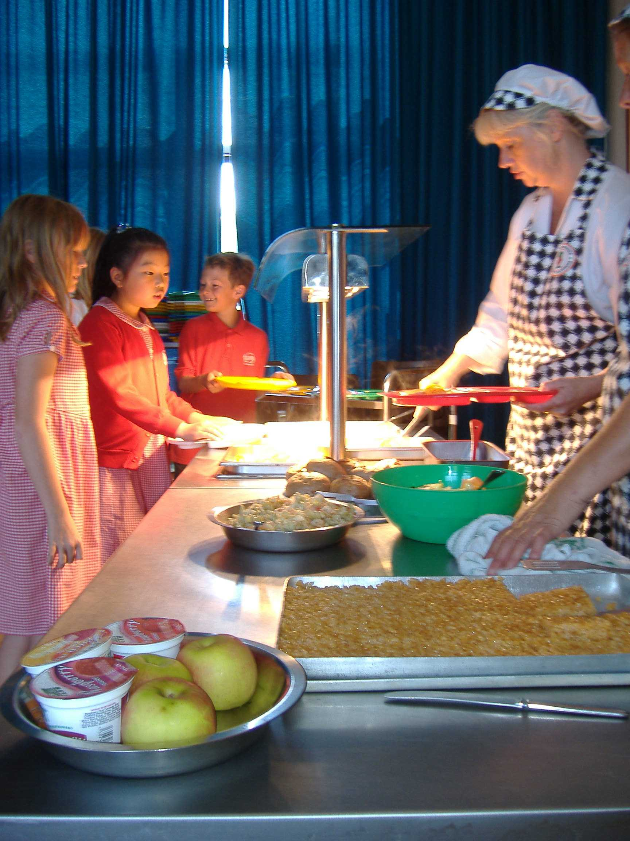Meals presently cost £2.10 per day / £10.50 per week (there may be a slight increase in September 11). Dinner money should be paid in advance on a Monday. You may pay for a term or half term in advance if you wish. You may be entitled to free school meals if you are claiming:
Income support Jobseekers Allowance
Child Tax Credit State Pension credit
Support under part IV of the Immigration & Asylum Act

Please call at the school office for more information.
Children may bring packed lunches to school and these are eaten in the school hall or outside in fine weather. These packed lunches should not include glass bottles or cans of drink; the drink container and the lunch box should be clearly marked with the child's name.

ParentPay payments to school

In an attempt to remove all cash and cheques from school we are asking all parents to only use our e-payment system to pay for dinner money, trips and all other school activities. This can be done online using a secure website called ParentPay.
ParentPay offers you the freedom to make payments whenever and wherever you like, 24 hours a day, 7 days a week – safe in the knowledge that the technology used is of the highest internet security available.
You have a secure online account, activated using a unique set of activation codes. You will be prompted to change these and create your own secure Username and Password for future logins. If you have two or more children at the school, you can merge their accounts once logged in.
Making a payment is straightforward and ParentPay holds an electronic record of your payments to view at a later date; no card details are stored in any part of the system.
Once you have activated your account you can make online payments straight away.
Parents may still pay by cash or cheque (please make cheques payable to Saltergate Junior School) at the school office. If you have to send money in to school please place it in a sealed envelope marked with your child’s name, class and what it is for.

Dropping off and picking up
For the convenience of parents, a voluntary one-way system operates in a clockwise direction on Newby Crescent. Unless you are collecting a sick child, we would be grateful if you did not bring cars down the drive into the school car park. Please note that the direction of the one way system might change this year. We will let you know if this happens.

Kids’ Club
The ‘Kids’ Club’, is an independent private business run by Mrs Pat Gallagher. It operates within the infant school and provides out of school care between 8.00am and 9.00am before school and from 3.00pm to 6.00pm after school. Bookings can be made by telephoning 07812 935137.

School Dress Code
Parents are requested to dress their children in appropriate school clothes. Options are listed below. The basic colours are red, white and grey.

Red or white blouse, shirt or polo shirt
Grey or black trousers or shorts for boys. Grey skirt, grey pinafore dress or red checked school dress for girls.
Red Jumper, sweat shirt or cardigan
Sensible shoes (not boots); shoes with small heels and no fastenings are unsuitable as they restrict children’s ability to play

Items of School Uniform with the school logo on can now be purchased at Rawcliffes, the school uniform shop in town.

Lost Property
Please mark all clothing with your child’s name. Lost items are placed in a tub in reception. We empty this regularly but can only return items to their owners if they are named. Please feel free to browse this tub at any time. Unclaimed clothes have to be disposed of at the end of each term.

Medicines
For the safety of all children we try to minimise the number of medicines in school. However, if your child is prescribed medication which has to be taken 4 times a day, or requires medication for emergencies (e.g. allergic reaction, migraines) it can be administered by school staff. Please take any such medicines to the office and complete the appropriate school paperwork.

If your child suffers from asthma and requires an inhaler, we need written advice from you on the condition and the required treatment. In most cases children will keep their inhaler with them, with a spare kept in a box in the classroom. All inhalers should be labelled with the child’s name.

Extra Activities
Clubs vary from year to year, according to the interests of the children and staff. They have included the following:

Football | Drama
Choir | Cricket
Dance | Computer
Sports | Crafts
Recorder | Orchestra

All our clubs are free of charge.

Peripatetic Music Lessons
At the end of Year 3 (and subsequent years) children and their parents are encouraged to consider the option of learning a musical instrument with one of the visiting peripatetic
music teachers, who are employed by North Yorkshire County Music Service. Possible tuition is in violin, viola, cello, cornet, trumpet, trombone, flute, oboe, clarinet, saxophone, guitar, keyboard, drums and percussion. 25 group lessons of 30 minutes are offered per academic year (although every effort is made to provide 30 lessons per year). There is the opportunity for parents to attend a parents evening to discuss their child’s progress and twice a year the end of the autumn term and during the summer term parents receive a written progress report.

This is a valuable “extra curricular” activity that we promote at Saltergate. Fees are applicable for this and are collected termly in advance by County Hall, they can also be paid by direct debit, which spreads the annual cost over nine monthly instalments. For children of parents on lower incomes, subsidies are available which further reduce the cost. School may also be able to help with the loan of an instrument. For more information please see Mrs Amos or the School Office.

Cloakrooms
As our cloakrooms are very small for the number of children we have, they get overcrowded very easily. It would be helpful if children did not bring big bags to school, as we have nowhere to store them. A PE bag containing PE kit can be left on the child’s peg during the week. Home work books and reading books, can be brought to school in a book bag, these can be purchased from Rawcliffes. Older children often prefer to use their own bags but can we ask that they are as small as possible. Those children bringing a packed lunch should place it on the shelving above the coat pegs.

Healthy Tuck Shop
At morning break a variety of snacks is available each costing 25p. There is usually a choice between fruit, fruit juice, vegetable sticks, dried fruit and milk. Children may bring similar items from home but should not bring chocolate, crisps, cereal bars etc. They should not eat any items from their packed lunches at break apart from these.

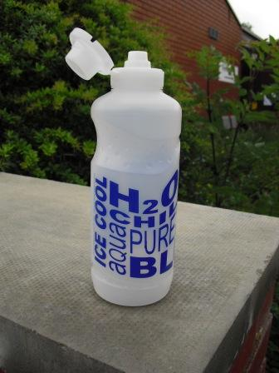Bring Water Every Day
We strongly encourage children to bring a drink of water in a bottle that they can keep in their bag. They have access to this at the beginning and end of every lesson – if they finish it they can fill their container at the classroom tap. Recent research highlights the importance of children drinking plenty of water. Water bottles can be bought from the school office, at a cost of £1.00. Please ensure water bottles are taken home and cleaned on a regular basis.

Mobile Phones
We regret that we are unable to ensure the safekeeping of mobile phones and strongly recommend that they are not brought into school.

PE and Games
We give girls and boys equal opportunities in all sporting activities. P.E. and Games are important and compulsory parts of the school curriculum. All children take part unless there is a medical reason. We have a well-equipped hall for gymnastics and a good supply of apparatus for general games skills. Swimming is currently provided for children in Years 3 and 4.
The school enters teams in local sporting competitions whenever possible.

Clothing for P.E. should be brought on Monday and kept in school until Friday, when it can be taken home to be washed. These clothes are for P.E. lessons only - we expect children to change for this lesson. The guidelines from NYCC state that no jewellery, including ear studs, should be worn during P.E. lessons. If your child wears ear studs they should bring a small box to keep them safe during these lessons.

We now have a changing room allowing separate changing for our older boys and girls.

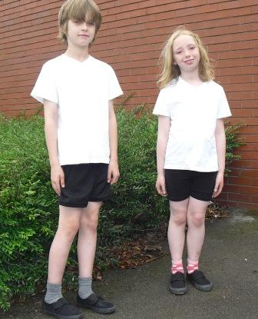Children need to bring:

- draw-string bag

- plain white t-shirt or polo shirt

- white or black shorts

- trainers for outdoor PE

- plimsolls for indoor PE

- baseball cap for summer

- track suit bottoms, warmer shirt for winter.

ICT

ICT is now taught by class teachers in their classrooms. Each class has 7 laptops which are used by groups in many lessons. Whilst we still have a suite of 27 computers these are now quite old and will not be replaced when they are obsolete. The suite has served us well over the years but we now want IT to be in use in the classrooms. Every child has his/her own ‘My Work’ folder that can be accessed from any of the schools computers. Children learn to use the Internet, email and digital cameras. Whilst they have access to a vast range of educational software, pupils are also taught to use the common Microsoft programmes. Interactive white boards are used in all classrooms providing high quality visual support for lessons. Internet resources are regularly used to aid teaching. Laptops with appropriate software are available to help children with special needs.
Children follow a safe Internet code and web sites are filtered.

We teach children to use e-mail responsibly and give them each their own ‘account’ and password when they start on this topic.

Our Internet use policy is displayed in the computer suite and is explained to all children. It is available on the website for parents to see.

Drugs Education
This subject is addressed in both PSHCE and science.

The lessons explore the idea that all medicines are drugs but not all drugs are medicines. We try to help children live safely in a world of drugs.

School Council
Representatives from each class meet with the Headteacher to discuss developments in school. They have helped with major decisions about building work, incentive systems and much more. Their work is displayed on a board in the hall for all to see.

Special Educational Needs
The school will endeavour to meet the needs of all its children.

Most needs can be met through careful adaptation of normal lessons and, if necessary, support from a teaching assistant – this stage of help is called School Action as defined by the DfES code of practice. If this level of intervention does not restore a reasonable level of progress, then programmes of work in addition to or instead of normal lessons may be introduced – this stage is called School Action Plus. Outside agencies may be involved at this stage. In very exceptional cases children may undergo a statutory assessment of their needs possibly leading to a statement.

Our resources for meeting special needs are excellent: eight teaching Assistants working over 180 hours a week between them. Assessment of needs and deployment of resources within school is managed by Mrs Hollywood.

Homework

Children will:
- be asked to learn a few spelling or tables each week until they are secure in these.

- need to read a little most days - to be recorded in a reading record. Regular reading will be rewarded.

- be set a task each week. These will become longer and more involved as they get older.

- Be set one project each year. There may be some choice of theme.

Children will need:
Peace and quiet away from the TV!
A table or desk
A calculator
Pencils, crayons and a ruler
A suitable dictionary and an atlas if possible

A computer with a word processor, printer and Internet access is really useful. Though not yet essential, it is becoming more and more important for all learning.

Do Children have to do it?
Yes! We expect children to do the tasks we set. They are an important part of their learning and they will probably enjoy it. We will contact you if your child is not doing their homework.

If you have any questions about specific tasks please contact the teacher. If you have general questions about homework please contact Mr Taylor.

Sex Education
The Governing Body and teaching staff, following consultation with parents have incorporated Sex Education into the curriculum. This is a part of our Personal, Social, Health and Citizenship Education programme.

In Year 5 children are given specific sex education lessons that look at the human life cycle including sexual reproduction. We feel that sex education is very much a partnership between parents and school and we hope that you will be able to build on the start we make in this important area of development. Parents have the right to withdraw their child from these lessons – if this is the case please let the class teacher know.

Events
Throughout the year, ‘one-off’ events punctuate the curriculum – these help broaden the children’s experience and add interest to school life. They may be live performances by theatre groups or musicians, visiting speakers or perhaps special days addressing a particular issue.

Educational Visits
At times during each school year, children will take part in visits as part of their studies. The highlight of the educational visits in Year 6 is usually a residential visit of 5 days duration to an Outdoor Activities Centre in the Lake District. Children take part in a variety of exciting activities and benefit socially from the experience. They learn to work together and get to know their teachers really well right at the start of this important year.

Charging Policy

We do our very best to make sure that school is not too expensive for parents and that children have equal access to opportunities associated with school.

- We never request contributions for events happening in school time such as theatre groups.

- We do not charge for after school activities, unless we employ an instructor and then we may make a small charge to help cover the costs.

- We hire an orchestra teacher for those children who are learning an instrument with a peripatetic teacher at no cost to parents.

- We cover two thirds of the cost of the Y6 residential with grants

However, we do have to ask for voluntary contributions for the cost of off-site visits, as these are too costly for the school to fund, especially if coach transport is involved. Wherever possible we subsidise these trips for everyone with funds kindly raised by the ‘Friends’. We also try to make sure that there is only one costly visit in each school year.

Communications

The school website is a good source of information about the school. Holiday dates, important letters and policies are all easily accessible.

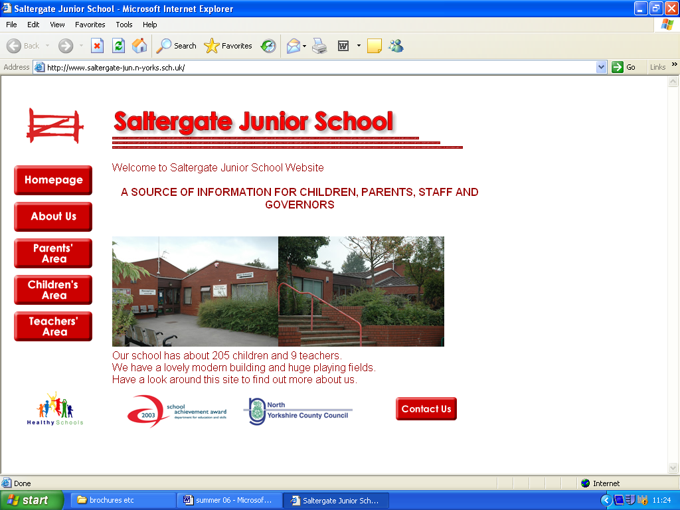

www. saltergate-jun.n-yorks.sch.uk

Newsletters are sent home with children each half term. Other information is sent home as needed. Please check bags for letters!

Parent Teacher Consultations
These are held three times a year, in the Autumn, Spring and Summer Terms, to give you an opportunity to exchange information with your child's class teacher and discuss their progress.

Friends' Association
The Friends of Saltergate Junior School organise social events for children and parents and many fund raising activities. If you can help in any way please let your child's class teacher know. The Friends meet after school once or twice each term (children can use the computer room whilst meetings are taking place).

Parent Helpers
We very much welcome parent helpers. Please ask any member of staff if you would like to help in any way. For the protection of all children we ask that parents apply for CRB clearance. Helpers awaiting clearance must never work alone with children. CRB forms are available from the office.

Home School Link Worker

Val Shaw is our current Link Worker. She generally works in the Infant School in the mornings and our school in the afternoons. She is available to help children and parents with any difficulties they may have. You can contact Val via the office or come and see if she is available. The end of the school day is a good time to catch her.

If things don’t seem to be going to well;

Losing interest,
Problems with friends,
Unhappy in class,

Val has the time and expertise to find the cause and help with the solution. Val can also help you access help from outside agencies if required.

Behaviour
We have a detailed and regularly reviewed behaviour policy in four parts: principles, incentives, consequences and bullying. The full version is available on the website or can be obtained from the office. The key points can be summed up as follows:

We endeavour to teach and encourage good behaviour but there are sanctions for poor behaviour:

Good behaviour is taught in PSHCE lessons and encouraged with an award system leading to a series of certificates. Smiley faces are stamped on a card to reward sensible behaviour, helpfulness, politeness and effort in improving behaviour when necessary. Children may receive a note home in the form of a ‘Saltergram’ in recognition of their good behaviour. Each week children who have received one are entered into a draw to win a small prize, which is presented in assembly.

Serious misbehaviour is recorded in what has come to be known as ‘the green book’ and two records within one term lead to parents being informed of both incidents. In persistent cases exclusions will, and have been used, including permanent exclusions. Much work is done to prevent this from happening but, regrettably, it is inevitable in a very small number of cases in order to protect the education and welfare of other children.

Bullying is always acted upon. Every case is different and dealt with accordingly; our usual practice is to work through talking and persuasion and then through sanctions, as above, if the problems continue. In this way parents of the bully are informed if the problem persists.

Every school has one or two children with medically diagnosed conditions that seriously affect their behaviour. We do our utmost to support these children in school and to minimise disruption to both play and lessons.

The following behaviour code was created by our school council;

Do have safe hands and feet

Do not hurt anybody

Do be kind and helpful

Do not hurt people’s feelings

Do look after property

Do not waste or damage things

Do work hard

Do not waste anybody’s time

Do listen to people

Do not let yourself be distracted

Do be honest

Do not cover up the truth

Chris Taylor
(Headteacher)

